**Real-time Stabilization and 3D Reconstruction of Hand Gestures and Finger Movement Traces Using LED-Equipped Gloves**



*Use Case Specification Document*

**ML-01**

**Machine Learning**

**Version No. 1.0**

**Project Document Revision History**

| **VersionNumber** | **Date** | **Revision Author** | **Description of Revision** |
| --- | --- | --- | --- |
| 1.0 | 10/16/2024 | Zaynab Mourtada | Original |
|  |  |  |  |

| **Table of Contents** |
| --- |

**1. Introduction 3**

**2. Use Case Information 4**

2.1 Actors 4

2.2 Use Case Interaction 4

**3. Trigger 4**

**4. Pre-condition(s) 4**

**5. Post-condition(s) 5**

5.1 The virtual writing gesture is smoothed and accurately rendered in real-time as a 3D trajectory within the mobile app. 5

5.2 The smoothed virtual writing is displayed in 3D space, available for interaction and review on the mobile app interface. 5

**6. Use Case Swimlane (Activity) Diagram 5**

**7. Main/Basic Flow(s) of Events (Happy Path) 5**

7.1 Raw virtual writing gesture data is received from the image processing phase. 5

7.2 The system adjusts the data to standardize the length of the input signal. 5

7.3 The system checks the data for noise and reduces it to create a smoother trajectory. 5

7.4 Key features, including kinematic, geometric, and frequency-based attributes, are extracted from the trajectory. 5

7.5 The extracted features are normalized for consistent input into the machine learning model. 5

7.6 The processed data is input into a neural network model, which identifies spatial and temporal patterns within the virtual writing. 5

**8. Alternate/Exception Flow of Events 5**

8.1 The system receives raw virtual writing gesture data from the image processing phase. 5

8.2 The system attempts to standardize the input signal length. 5

8.3 The system detects that the data quality is insufficient. 5

8.4 The system prompts the user to repeat the virtual writing gesture to capture improved data quality. 5

8.5 Once improved data is captured, the system resumes the main flow at the trajectory smoothing step. 5

**9. Assumptions/Business Rules including Non-Functional Requirements 6**

**9.1 Assumption 1: User has a compatible mobile device for the virtual writing app. 6**

**9.2 Assumption 2: User is trained on glove and app usage for virtual writing. 6**

**9.3 Assumption 3: Environment has adequate lighting and minimal interference. 6**

**9.4 Business Rule 1: System validates data quality; prompts user to repeat gesture if quality is low. 6**

**9.5 Business Rule 2: App operates in real-time with minimal latency. 6**

**9.6 Business Rule 3: App provides intuitive prompts for easy calibration and data capture. 6**

**9.7 NFR 1 – Security: Data is encrypted and stored securely, meeting privacy regulations. 6**

**9.8 NFR 2 – Reliability: 99% uptime to minimize interruptions. 6**

**9.9 NFR 3 – Usability: Accessible interface with adjustable fonts and clear prompts. 6**

**10. Use Case Specification Review and Signoff 6**

# Introduction

This use case outlines a machine learning module for adaptive HCI, optimized to smooth virtual writing trajectories in real-time. Upon receiving raw gesture data from the image processing phase, the module applies bicubic interpolation to standardize input signal length. For further noise reduction, a Kalman filter is utilized, followed by extraction and normalization of kinematic, geometric, and frequency-based features. The refined data is then processed by a hybrid LSTM-CNN model, where CNN captures spatial features and LSTM handles temporal dependencies. The final output is rendered as a smooth, accurate 3D trajectory on the mobile device and in AR/VR, supporting responsive and precise user interaction.

# Use Case Information

## Actors

| Actor Name | Role | Description |
| --- | --- | --- |
| System | Main | The end-user who interacts with the application. |
| User | Secondary | The entity that processes inputs and returns the outputs to the user. |

## Use Case Interaction

* Predecessor Use Case: Image Processing:

The system starts with the user wearing gloves and drawing in the air. The Image Processing use case captures and analyzes these gestures, converting them into 3D raw data. This processed data then serves as the input for the machine learning module, which smooths the writing trajectories.

* Successor Use Case: 3D Visualization:

After the machine learning module refines the gesture data, the smoothed writing is rendered in a 3D space. This final output can be viewed both within the app and in an AR/VR environment, allowing the user to interact with the 3D visualization of their writing in real-time.

# Trigger

The use case initiates when the system receives raw gesture data from the image processing phase, triggering the start of data standardization, noise reduction, and feature extraction for machine learning processing.

# Pre-condition(s)

**4.1** The user must wear the gloves designed for tracking virtual writing gestures.

**4.2** The user must access the mobile app to enable data processing.

**4.3** The user must perform virtual writing gestures in front of the camera.

**4.4** The image processor must successfully convert the virtual writing gestures into 3D trajectories for further analysis.

# Post-condition(s)

## The virtual writing gesture is smoothed and accurately rendered in real-time as a 3D trajectory within the mobile app.

## The smoothed virtual writing is displayed in 3D space, available for interaction and review on the mobile app interface.

* 1. The 3D virtual writing output is processed and available for viewing in AR/VR, allowing the user to engage with the writing in an immersive environment.

# Use Case Swimlane (Activity) Diagram

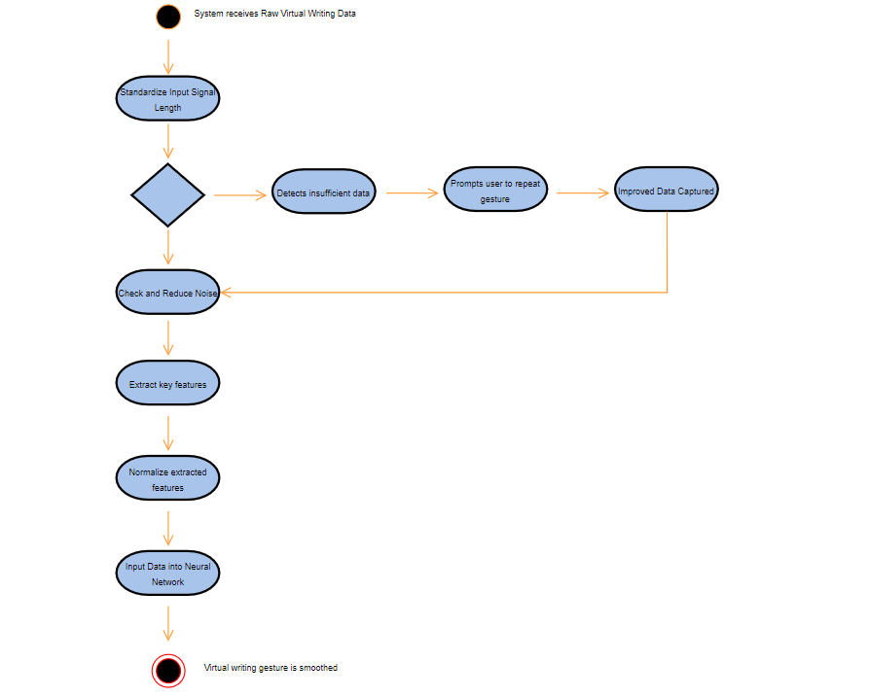

# Main/Basic Flow(s) of Events (Happy Path)

## Raw virtual writing gesture data is received from the image processing phase.

## The system adjusts the data to standardize the length of the input signal.

## The system checks the data for noise and reduces it to create a smoother trajectory.

## Key features, including kinematic, geometric, and frequency-based attributes, are extracted from the trajectory.

## The extracted features are normalized for consistent input into the machine learning model.

## The processed data is input into a neural network model, which identifies spatial and temporal patterns within the virtual writing.

# Alternate/Exception Flow of Events

## The system receives raw virtual writing gesture data from the image processing phase.

## The system attempts to standardize the input signal length.

## The system detects that the data quality is insufficient.

## The system prompts the user to repeat the virtual writing gesture to capture improved data quality.

## Once improved data is captured, the system resumes the main flow at the trajectory smoothing step.

# Assumptions/Business Rules including Non-Functional Requirements

# 9.1 Assumption 1: User has a compatible mobile device for the virtual writing app.

# 9.2 Assumption 2: User is trained on glove and app usage for virtual writing.

# 9.3 Assumption 3: Environment has adequate lighting and minimal interference.

# 9.4 Business Rule 1: System validates data quality; prompts user to repeat gesture if quality is low.

# 9.5 Business Rule 2: App operates in real-time with minimal latency.

# 9.6 Business Rule 3: App provides intuitive prompts for easy calibration and data capture.

# 9.7 NFR 1 – Security: Data is encrypted and stored securely, meeting privacy regulations.

# 9.8 NFR 2 – Reliability: 99% uptime to minimize interruptions.

# 9.9 NFR 3 – Usability: Accessible interface with adjustable fonts and clear prompts.

# Use Case Specification Review and Signoff

| Review and Signoff of the Use Case Specification | | | |
| --- | --- | --- | --- |
| Name | Project Team Role | Signature | Date |
| Soham Naik | Lead Image Processing & Computer Vision Engineer | [Soham Naik](mailto:sohamn@umich.edu) | 10/16/2024 |
| Deniz Acikbas | Lead Mobile App & VR/AR Engineer | [Deniz Acikbas](mailto:dacikbas@umich.edu) | 10/16/2024 |
| Zaynab Mourtada | Lead Machine Learning Engineer | [Zaynab Mourtada](mailto:zaynabmo@umich.edu) | 10/16/2024 |
| Alan Raj | Lead 3D Visualizer Engineer | [Alan Raj](mailto:alanraj@umich.edu) | 10/16/2024 |
| Xiao Zhang | Client |  | 10/16/2024 |

# 